Question Bank

Course Code: CSE 2024
Course name: NoSQL Databases Sections: 5CSE5,5CSE6,5CSE7
SL | Questions | C0 | L | M
1 | Describe the NoSQL Database and list the types of NoSQL Databases.  ANS : NoSQL is a database that does not require table-based relational models to hold structured, unstructured, and semi-structured data.  Types of NoSQL Databases:  Key Valued Storage  Document Storage  Column Storage  Graph Storage | 1 | 2 | 2
2 | Illustrate the Key Valued Storage model with an example.  ANS : Data is stored in key/value pairs. It is designed in such a way to handle lots of data and heavy load. Example : JSON, BLOB(Binary Large Objects), string, etc. | 1 | 3 | 5
3 | Illustrate the Document Storage model with an example.  ANS : Document-Oriented NoSQL DB stores and retrieves data as a key value pair but the value part is stored as a document. The document is stored in JSON or XML formats. | 1 | 3 | 5
4 | Illustrate the Column Storage model with an example.  ANS : Column-oriented databases work on columns and are based on BigTable paper by Google. NoSQL databases are widely used to manage data warehouses, business intelligence and Library card catalogues. | 1 | 3 | 5
5 | Illustrate the Graph Storage model with an example.  ANS : A graph-type database stores entities as well the relations amongst those entities. The entity is stored as a node with the relationship as edges. | 1 | 3 | 5
6 | Describe the concept of Concurrency.  ANS : Concurrency Control in Database Management System is a procedure of managing simultaneous operations without conflicting with each other.  It ensures that Database transactions are performed concurrently and accurately to produce correct results | 1 | 2 | 2
7 | Describe the concept of database integration  ANS : Database integration is the process used to aggregate information from multiple sources—like social media, sensor data from IoT, data warehouses, customer transactions, and more | 1 | 2 | 2
8 | Demonstrate the ACID properties of RDBMS with an example  ANS : ACID Properties are used for maintaining the integrity of the database during transaction processing.  The ACID in DBMS stands for Atomicity, Consistency, Isolation, and Durability. Example : Atomicity: A transaction is a single unit of operation.  consistency means that the value should remain preserved always.  The term 'isolation' means separation.  Durability ensures the permanency of something. | 1 | 3 | 5
9 | Describe the history of NoSQL  ANS : The concept of NoSQL databases became popular with Internet giants like Google, Facebook, Amazon, etc. who deal with huge volumes of data. The system response time becomes slow when you use RDBMS for massive volumes of data.  1998- Carlo Strozzi use the term NoSQL for his lightweight, open-source relational database and from 2000 o 2008 many others were launched and released then in 2009- The term NoSQL was reintroduced | 1 | 2 | 2
10 | Differentiate between horizontal scaling and vertical scaling  ANS : horizontal scaling add/increase of more machines or processors , it also called “scaling out”.  Vertical scaling adds more power to a single machine for running machine, it also called as “scaling up”. | 1 | 2 | 2
11 | Explain the Non-relational feature of NoSQL.  ANS : NoSQL databases never follow the relational model  Never provide tables with flat fixed-column records  Work with self-contained aggregates  Doesn’t require object-relational mapping and data normalization  No complex features like query languages, query planners. | 1 | 2 | 2
12 | Explain the Schema-free feature of NoSQL.  ANS : Schema-free  NoSQL databases are either schema-free or have relaxed schemas  Do not require any sort of definition of the schema of the data  Offers heterogeneous structures of data in the same domain | 1 | 2 | 2
13 | Explain the Simple API feature of NoSQL.  ANS : Simple API  Offer easy-to-use interfaces for storage and querying data provided  APIs allow low-level data manipulation and selection methods  Text-based protocol mostly used with HTTP REST with JSON  Mostly used no standard-based NoSQL query language | 1 | 2 | 2
14 | Explain the Distributed feature of NoSQL.  ANS : Distributed  Multiple NoSQL databases can be executed in a distributed fashion  Offers auto-scaling and fail-over capabilities  Often ACID concept can be sacrificed for scalability and throughput  Shared Nothing Architecture. | 1 | 2 | 2
15 | Demonstrate the BASE properties of RDBMS with an example  ANS : BASE - Basically Available, Soft state, Eventual consistency  Definition: An alternative to the ACID data processing model.  Basically, available means DB is available all the time as per CAP theorem  Soft state means even without input; the system state may change  Eventual consistency means that the system will become consistent over time.  Example :  Using shopping cart applications on a website.  Monitoring network and IT infrastructure security  Managing and reusing document content | 1 | 3 | 5
16 | Differentiate between ACID and BASE properties  ANS :  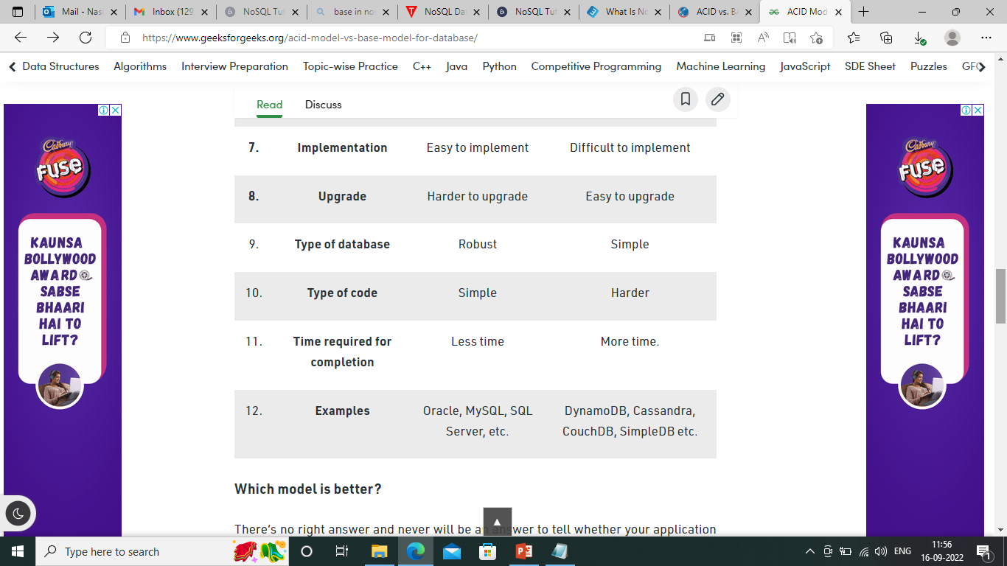  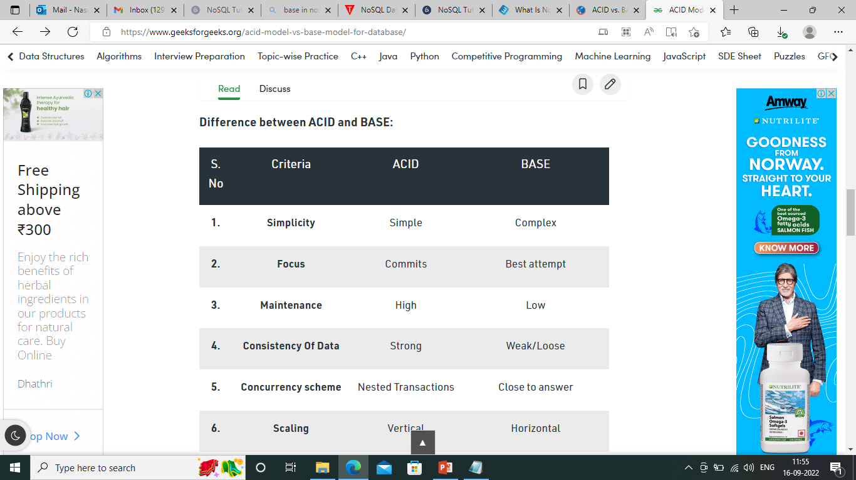 | 1 | 2 | 2
17 | Explain CAP theorem  ANS : CAP – Consistency , Availability, Partition Tolerance  CAP Theorem: The CAP theorem is also called the brewer’s theorem. It states that is impossible for a distributed data store to offer more than two out of three guarantees:  Consistency  Availability  Partition Tolerance. | 1 | 2 | 2
18 | Describe database Sharding with an example  ANS : Sharding is a method for distributing a single dataset across multiple databases, which can then be stored on multiple machines.  Sharding is a form of scaling known as horizontal scaling or scale-out.  Horizontal scaling allows for near-limitless scalability to handle big data and intense workloads.  vertical scaling refers to increasing the power of a single machine or single server through a more powerful CPU, increased RAM, or increased storage capacity. | 1 | 2 | 2
19 | Describe database replication with an example  ANS : If your data workload is primarily read-focused, replication increases availability and read performance while avoiding some of the complexity of database sharding. | 1 | 2 | 2
20 | Explain the advantages of NoSQL  ANS : Can be used as a Primary or Analytic Data Source  Big Data Capability  No Single Point of Failure  Easy Replication  No Need for Separate Caching Layer  It provides fast performance and horizontal scalability.  NoSQL databases don’t need a dedicated high-performance server | 1 | 2 | 2
21 | Explain the disadvantages of NoSQL  ANS : No standardization rules  Limited query capabilities  RDBMS databases and tools are comparatively mature  Doesn’t work as well with relational data  The learning curve is stiff for new developers  Open source options so not so popular for enterprises. | 1 | 2 | 2
22 | Explain the concept of collections in NoSQL  ANS : A collection is a group of documents. Collections typically store documents that have similar contents.  Not all documents in a collection are required to have the same fields, because document databases have a flexible schema. | 2 | 2 | 2
23 | Describe the naming conventions in NoSQL Databases  ANS : MongoDB has some naming conventions. One of them is that database names are case insensitive.Example :Database  camelCase: append DB to the end of the name | 2 | 2 | 2
24 | Explain the key features of Document Databases  ANS : Document model: Data is stored in documents (unlike other databases that store data in structures like tables or graphs)  Flexible schema: Document databases have a flexible schema, meaning that not all documents in a collection need to have the same fields.  Distributed and resilient: Document databases are distributed, which allows for horizontal scaling and data distribution.  Querying through an API or query language: Document databases have an API or query language that allows developers to execute the CRUD operations on the database | 2 | 2 | 2
25 | Describe the Strengths and Weaknesses of Document Databases  ANS : Strengths : Document Model  Flexible Schema  APIs and Query Languages  Distributed and Resilient.  Weakness: A common weakness that people cite about document databases is that many do not support multi-document ACID transactions. | 2 | 2 | 2
26 | Illustrate the CRUD operation in the NoSQL Database  ANS : CRUD (create, read, update, and delete) operations.  Create: Documents can be created in the database. Each document has a unique identifier.  Read: Documents can be read from the database. The API or query language allows developers to query for documents using their unique identifiers or field values.  Update: Existing documents can be updated — either in whole or in part.  Delete: Documents can be deleted from the database. | 2 | 3 | 5
27 | Illustrate the concept of Indexing in NoSQL Databases  ANS : Indexes support the efficient resolution of queries.  Without indexes, MongoDB must scan every document of a collection to select those documents that match the query statement.  This scan is highly efficient and requires MongoDB to process a large volume of data.  Indexes are special data structures, that store a small portion of the data set in an easy-to-traverse form.  The index stores the value of a specific field or set of fields, ordered by the value of the field as specified in the index. | 2 | 3 | 5
28 | Illustrate the concept of replication in NoSQL Databases.  ANS : Replication is the process of synchronizing data across multiple servers.  Replication provides redundancy and increases data availability with multiple copies of data on different database servers.  Replication protects a database from the loss of a single server.  Replication also allows you to recover from hardware failure and service interruptions.  With additional copies of the data, you can dedicate one to disaster recovery, reporting, or backup. | 2 | 3 | 5
29 | Illustrate the concept of sharding in MongoDB  ANS : Sharding is the process of storing data records across multiple machines and it is MongoDB's approach to meeting the demands of data growth.  As the size of the data increases, a single machine may not be sufficient to store the data nor provide an acceptable read and write throughput.  Sharding solves the problem with horizontal scaling. With sharding, you add more machines to support data growth and the demands of reading and writing operations. | 2 | 3 | 5
30 | Explain update consistency with an example.  ANS : Consistency is the property of the database management systems in which a consistent state is maintained in the database.  Write-Write Conflict: Two People Updating the Same Data at the Same Time.  When These Writes reach the server, the Server Will Serialize Them After one Other.  Person A – Update is Overwritten By Person B- Update. | 2 | 2 | 2
31 | Explain read consistency with an example.  ANS | 2 | 2 | 2
32 | Illustrate the approaches to maintain the update consistency  ANS : Pessimistic: “ Preventing Conflict”  Common Approach: To Have a write lock in order to change a value you need to acquire a lock and the system ensures that only one client can get a lock at a time.  Optimistic: “Let conflict occur, but detects them and takes action to sort them out.”Common Approach: Conditional Update, any client that does an update tests the value just before updating it to see if it’s changed since his last read.  To Save both updates and record that they are in conflict.  Version Control: Merge the two updates maybe you show both values to the user and ask them to sort it out or the computer can merge itself | 2 | 3 | 5
33 | Explain the Inconsistency Window.  ANS : Inconsistency Window:  The Length of time inconsistency is present is called the inconsistency window.  “A NoSQL System may have a quite short inconsistency window. Usually less than a second.” | 2 | 2 | 2
34 | Describe the sticky sessions.  ANS : “A Sticky Session allows you to ensure that as long as you keep reading –your –writes consistently on a node you will get it for sessions too. The downside is that sticky sessions reduce the ability of the load balancer to do its job.” | 2 | 2 | 2
35 | Explain the version stamping.  ANS : Version Stamps  Another approach for session consistency is to use Version Stamps and ensure every interaction with the data store includes the latest version stamp seen by a session. | 2 | 2 | 2
36 | Explain capped collections with an example  ANS : Not available in module. | 2 | 2 | 2
37 | Demonstrate the following operation in MongoDB  - Create a database. “ Library “  - Create a collection of “ Books.”  - Add 10 documents with the following fields- B_id Bname, ISBN,  Pages, Price, Author_name | 1&2 | 3 | 25

- Display the book name with a price of more than 100 rs
- Display the book name with a number of pages more than 500 pages
- Update the price of a book with ISBN "123456" to 150 RS.
- Delete the collection
- Delete the database
38 | Demonstrate the following operation in MongoDB.  - Create a new MongoDB database named "StudentDB" and within it, create a collection named "Students."  - Insert 5 new student records into the "Students" collection with details like student name, student ID, date of birth, major, and CGPA.  - Find and display all students in the "Students" collection majoring in a specific field (e.g., "Computer Science").  - Retrieve and display student details for students with a specific GPA (e.g., GPA > 3.5).  - Update the major for a student with a specific student ID to "Biology."  - Delete all students in the "Students" collection born before a specific date.  - Remove the entire "Students" collection from the "StudentDB" database.  - Delete the entire "StudentDB" database from your MongoDB server. | 1&2 | 3 | 25
39 | Demonstrate the following operation in MongoDB.  - Create a new MongoDB database named "EmployeeDB" and within it, create a collection named "Employees."  - Insert 5 new employee records into the "Employees" collection with details like employee name, employee ID, department, salary, and hire date.  - Find and display all employees in the "Employees" collection who belong to a specific department (e.g., "Sales").  - Retrieve and display employee details for employees with salaries in a specific range (e.g., $50,000 - $60,000).  - Update the salary for an employee with a specific employee ID to  $65,000.  - Delete all employees in the "Employees" collection hired before a specific date.  - Remove the entire "Employees" collection from the "EmployeeDB" database.  - Delete the entire "EmployeeDB" database from your MongoDB server. | 1&2 | 3 | 25
40 | The company “xyz Infotech” wants to recruit a few final-year students. Design an aggregation pipeline for the following company requirements  - CGAP > 7.5  - Domain: “Machine Learning”  - More than 85 marks in DS and DAA  - More than 20 Git repositories  - Group the students by Domain  - Display the aggregation output and count | 1&2 | 3 | 25

41 | "xyz Infotech" is a growing company looking to recruit new employees for various departments. To ensure they hire the right candidates, they have specific criteria that candidates must meet. After recruitment, they want to group the employees by department to manage their workforce  better.  - Criteria for Recruitment:  - Minimum experience of 3 years.  - Skills in Java programming.  - Educational qualification: Bachelor's degree or higher in Computer Science or a related field.  - Grouping by Department: Group the recruited employees by their respective departments.  - Display Results: Display the aggregation output, including the list of employees in each department and the count of employees in each department.  - Index the collection by experience | 1&2 | 3 | 25
42 | Demonstrate replication setup in mongoDB  - Create one primary node  - Create two secondary nodes  - Create a replication set “Exam”  - Add all the nodes to “Exam”  - Remove all nodes and delete the replication set created  ANS : Replication  1 Use local.  1.dB.system.replset.deleteMany({}).  1 Exit.  1 Delete all nodes.  1 Run or start service.  1 Run as administrator.  1 CD/.  1 Mkdir c:\nade1\data c:\nade1\log c:\nade1\config.  1 Mkdir c:\nade2\data c:\nade2\log c:\nade2\config.  1 CD node1.  1 CD config.  1 Notepad mongod.cnf.  1 Copy and paste the data , log( mongod.log) , port to notepad from node1 file.  1 Then save the info in node 1 config file .  1 Cd/.  1 Node2.  1 CD config.  1 Notepad mongod.cnf.  1 Copy and paste the data , log( mongod.log) , port to notepad from node2 file.  1 Then save the info in node 2 config file .  1 Cd\.  1 Remove # in config file in program file (write exam instead of rs0).  1 Save and restart the services.  1 mongod --dbpath ( datapath) --logpath ( logpath mongod.log) port = 27017 --replset exam .  1 mongosh --port 27017  1 rsconfig = {_id:"exam", members: [{_id:0, host: "localhost:27017"}]}.  1 rs.initate( rsconfig ).  1 cd\.  1 mongod --dbpath ( datapath) --logpath ( logpath mongod.log) -- port 27020 --replSet exam.  1 take new CMD as administrator.  1 cd\.  1 mongod --dbpath ( datapath) --logpath ( logpath mongod.log) -- port 27030 --replSet exam.  1 take new CMD as administrator.  1 Cd\.  1 Mongosh.  1 rs.add("localhost: 27020")  1 rs.add("localhost: 27030")  1 rs.status().  1 take new CMD as administrator.  1 cd\.  1 mongosh -- port 27020.  1 Show dbs.  1 take new CMD as administrator.  1 cd\.  1 mongosh -- port 27030.  1 Show dbs.  Deleting:  1 Close all cmd tabs .  1 delete all nodes.  1 put # ( comment out) in config file .  1 restart the services .  1 open cmd type mangosh , it should appear test . | 1&2 | 3 | 25

